**1.Selection sort**

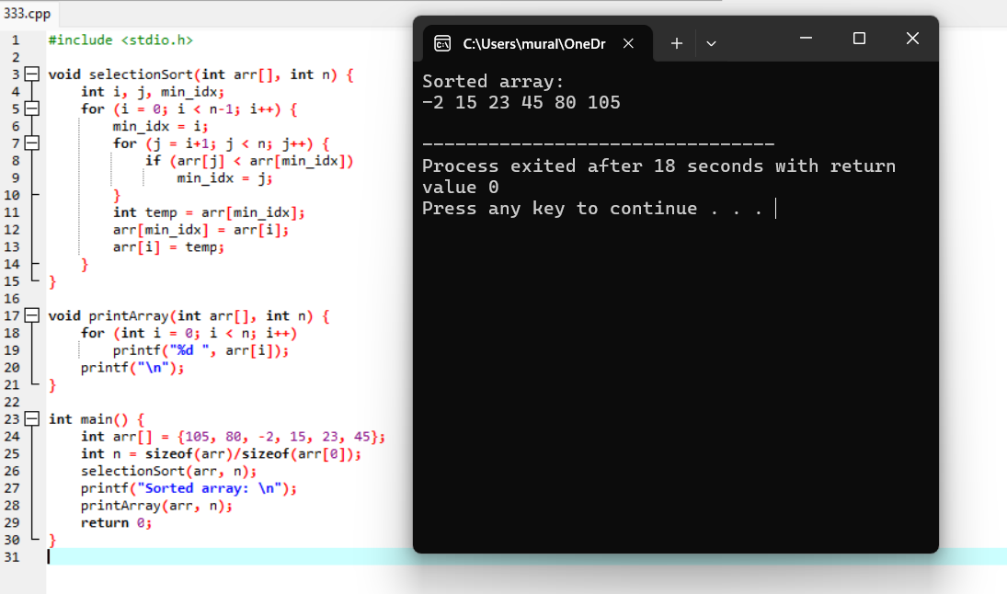

**2.** **Perfect Number**

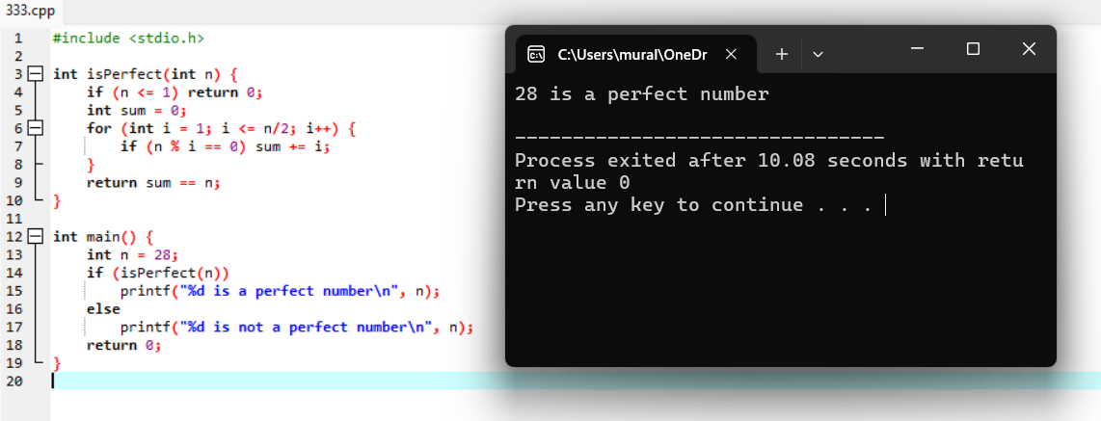

**3.** **Even Sum of Fibonacci Series Till number N**

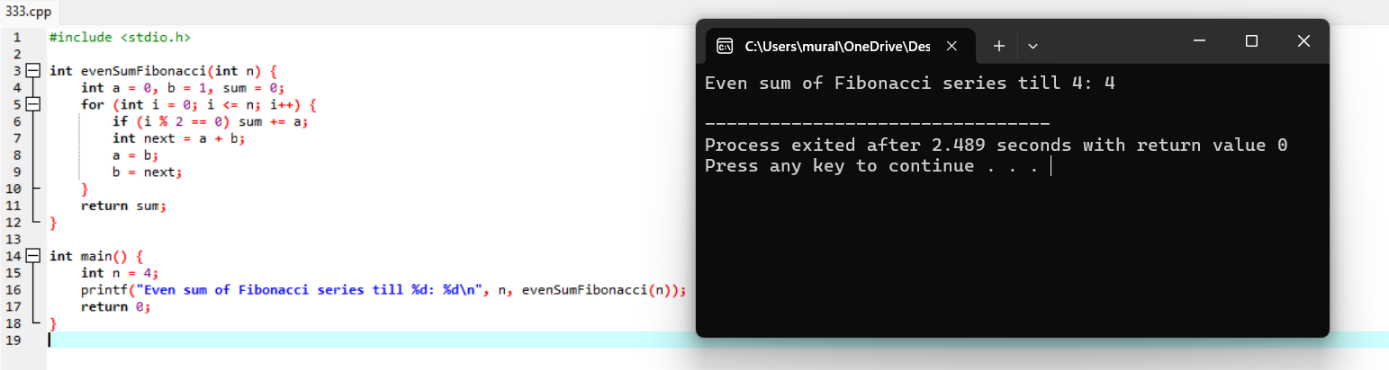

**4. Quick sort**

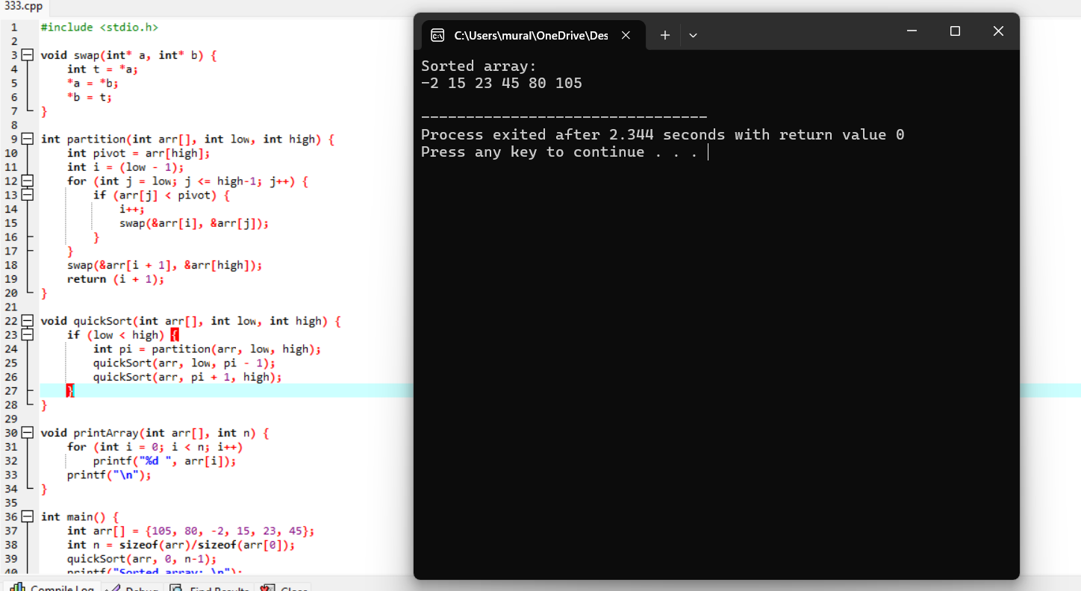

**5.** **First 2 minimum values from the numbers**

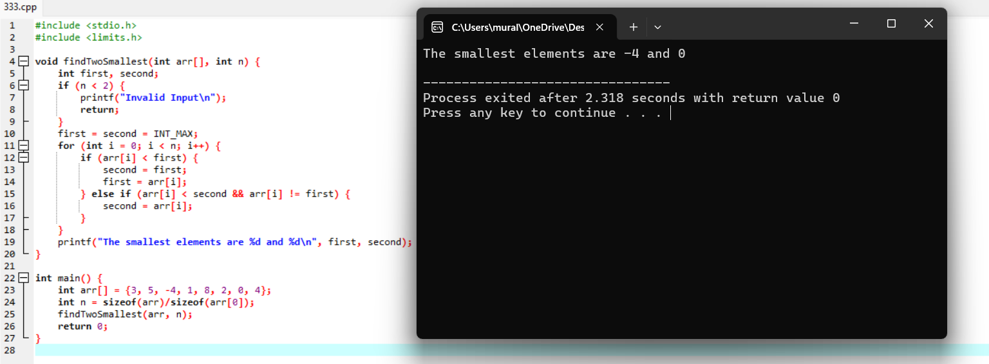

**6.** **Bubble sort**

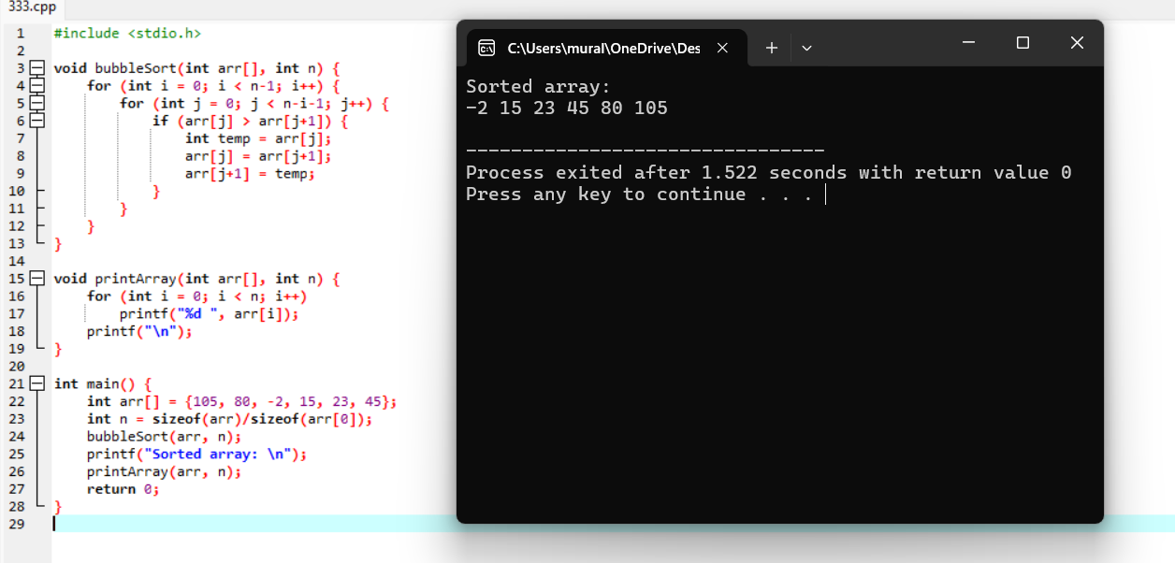

**7.** **Optimal Binary Search Tree**

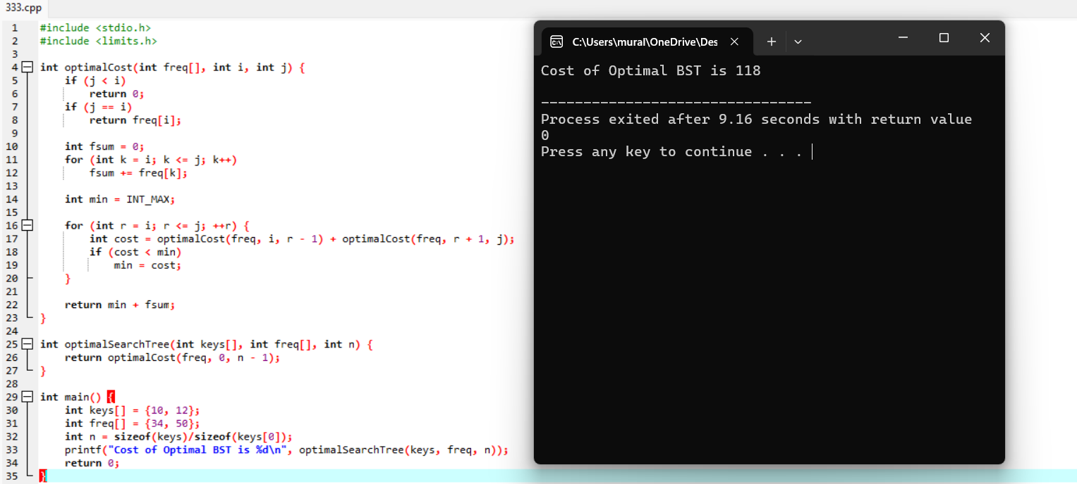

**8.** **Permutation Of An Array**

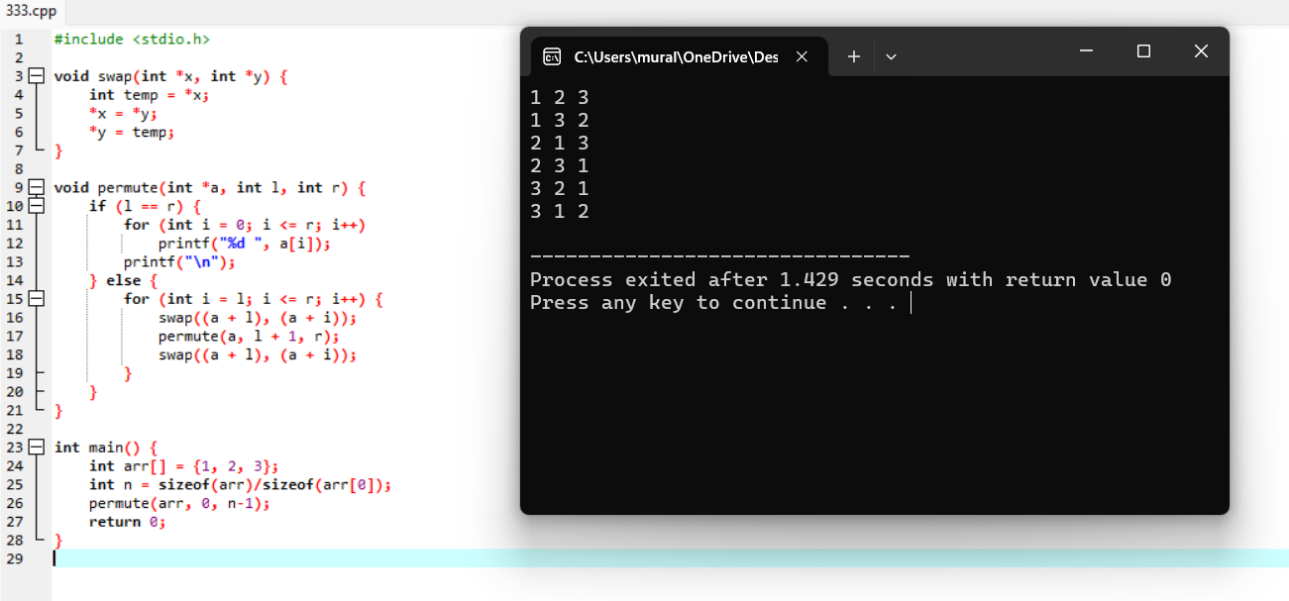

**9.** **Strassen’s Matrix Multiplication**

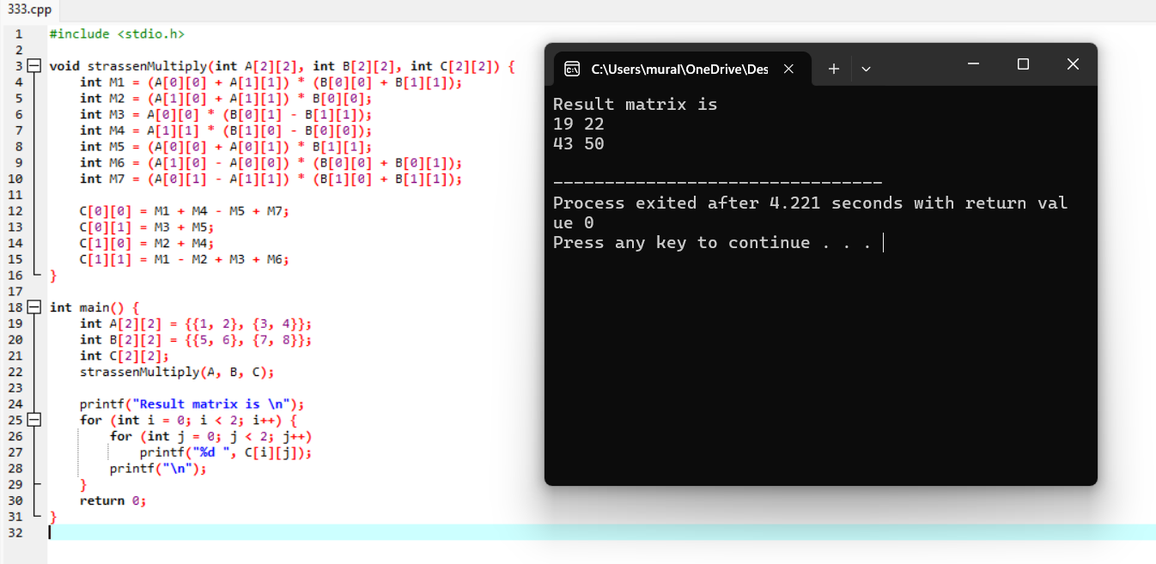

**10.** **Insert A Number In A List**

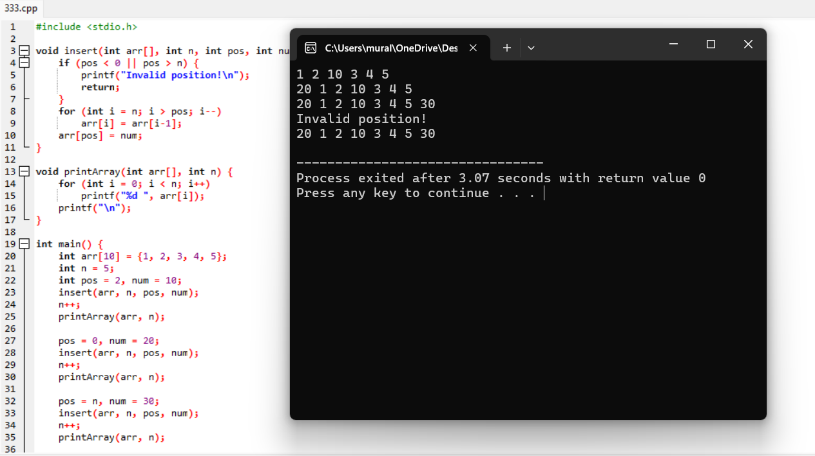

**11.** **Linear Search**

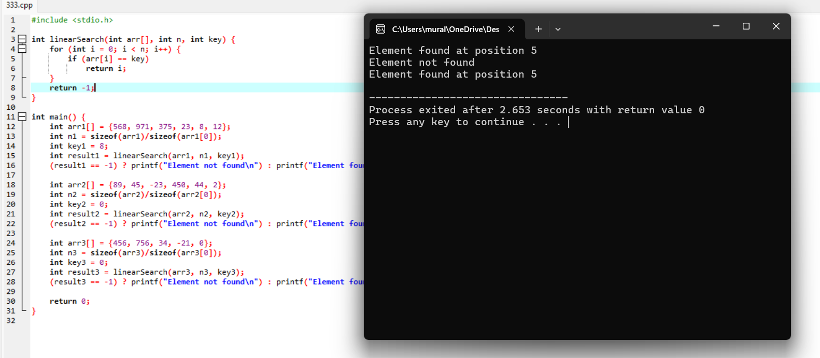

**12.** **GCD Of Two Numbers**

